|  |  |  |
| --- | --- | --- |
| **K** | **Final!!** | **Time Limit:**  **1 sec** |

The knockout stage of the world cup has already begun and everyone is trembling with excitement for their favorite team in this world cup. Surprisingly, you are feeling relaxed because you already know whether your favorite team **(team 7)** has a good chance of going to the world cup final or not.

You have the data of the number of head to head matches between two teams and the result (win or lose). The figure shows the bracket of the knockout stage. The number in the box shows the position of the teams.

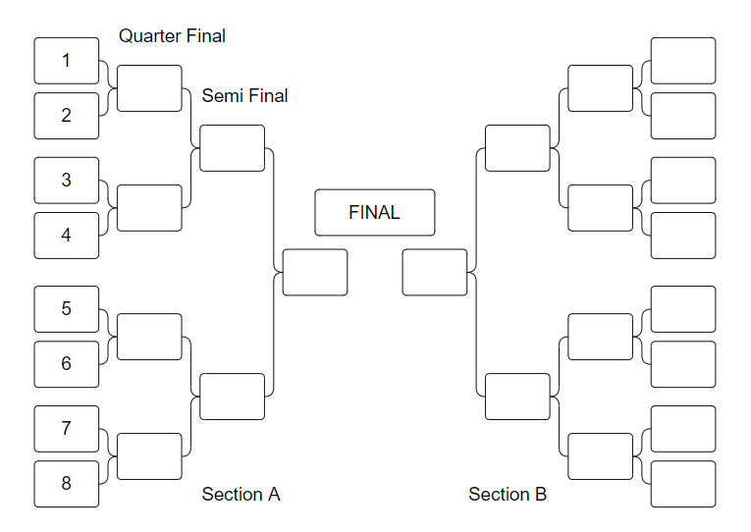

If you want to calculate the probability of going to the final of a team in Section A, you only require the data for the 8 teams in that section for your analysis. The explanation section describes one example process of calculating the probability.

#### **NOTE: You will find the data at the end of the problem.**

**Input**

The program does not require any input.

**Output**

Print the probability value (rounding up to two decimal places) of your favorite team going to the final.

**Data and Explanation**

See the next page for data & explanation.

|  |  |  |  |  |
| --- | --- | --- | --- | --- |
| Team (i) | Team (j) | Number of matches | Number of matches team i wins against team j | Number of matches team i loses against team j |
| 1 | 2 | 20 | 5 | 15 |
| 1 | 3 | 30 | 15 | 15 |
| 1 | 4 | 5 | 2 | 3 |
| 2 | 3 | 8 | 3 | 5 |
| 2 | 4 | 6 | 6 | 0 |
| 3 | 4 | 10 | 5 | 5 |
| 5 | 6 | 12 | 8 | 4 |
| 5 | 7 | 10 | 6 | 4 |
| 5 | 8 | 6 | 4 | 2 |
| 6 | 7 | 9 | 4 | 5 |
| 6 | 8 | 1 | 1 | 0 |
| 7 | 8 | 3 | 2 | 1 |
| 1 | 5 | 4 | 0 | 4 |
| 1 | 6 | 7 | 4 | 3 |
| 1 | 7 | 6 | 2 | 4 |
| 1 | 8 | 20 | 12 | 8 |
| 2 | 5 | 8 | 4 | 4 |
| 2 | 6 | 4 | 2 | 2 |
| 2 | 7 | 6 | 2 | 4 |
| 2 | 8 | 11 | 10 | 1 |
| 3 | 5 | 5 | 4 | 1 |
| 3 | 6 | 6 | 4 | 2 |
| 3 | 7 | 5 | 3 | 2 |
| 3 | 8 | 6 | 1 | 5 |
| 4 | 5 | 5 | 3 | 2 |
| 4 | 6 | 2 | 1 | 1 |
| 4 | 7 | 8 | 3 | 5 |
| 4 | 8 | 7 | 2 | 5 |

##### **We only consider the matches where a team wins or loses**

**Explanation:**

For example, we want to calculate the probability of going to the world cup final for **team 1**.

Let, **W ( i , j )** = the probability of team i wins against team j

**L ( i , j )** = the probability team i loses against team j

Here,

**W (1, 2) = 5/20 = 0.25**

**L (1, 2) = 1 – W (1, 2) = 0.75**

**W (2, 1) = L (1, 2) = 0.75**

**L (2, 1) = W (1, 2) = 0.25**

(We do not need to consider the probability of the draw for a team)

First, we want to calculate the probability of the event of going to the semifinal of **team 1**. There are two possible ways that event can happen.

1. **Team 1** must wins against **team 2**, **team 3** can win against **team 4** and **team 1** must win against **team 3**
2. **Team 1** must win against **team 2** and **team 3** can lose against **team 4** (same as **team 4** can win against **team 3**) and **team 1** must win against **team 4**

Therefore, the probability of team 1 going to the semifinal,

**WQF(1) = W(1,2) * W(3,4) * W(1,3) + W(1,2) * L(3,4) * W(1,4)**

In this similar way, you can easily calculate the probability of going to the final of **team 1** and **the probability value is**

**= WQF(1) * WQF(5) * W(1,5) + WQF(1) * WQF(6) * W(1,6) + WQF(1) * WQF(7)* W(1,7) + WQF(1) * WQF(8)* W(1,8)**